**Dr.M.G.R Government arts and science college for women**

**BUILD EMPLOYEE TRAVEL APPROVAL APPLICATION FOR CORPORATES**

Introduction

* 1. overview:

Employees travel on business trips to attend conferences, perform research, scout potential locations, meet suppliers, visit clients, and for numerous other essential reasons. Whatever the reason, such trips enable them to seek lucrative opportunities, build relationships, solve problems, enhance productivity, and drive growth.

Unfortunately, a persistent problem facing many with such aspirations is that they often find themselves in situations where the trips become a tiresome burden with exponentially higher costs than expected.

Why is this, you wonder? Simply put, the chaotic, frustrating, and challenging task of working with outdated spreadsheet-based systems makes business travel nightmarish every step of the way.

This problem is especially true for the archaic travel approval process, which makes trips unmanageable and unfeasible. We are here to tell the readers they don’t need to be.

This article will explore the travel request approval process, the challenges organizations face using older processes, and how creating a clear, automated workflow can help overcome these challenges. By the end of this article, you will understand why creating an ideal travel request approval workflow is essential to succeed in today’s competitive business environment.

What is a travel request approval process?

A travel request approval process is a series of actions that an employee or traveler follows to acquire management consent to implement a trip.

This process typically begins with the employee filling out a travel request form outlining the trip’s details, including the destination, purpose, dates, and estimated expenses.

The employee then forwards the request to the assigned administrative authorities and stakeholders through outdated methods of communication, such as email, for review. The review process involves managers and admins checking compliance with travel policies, estimating trip feasibility, verifying budget availability, and obtaining approvals from the other relevant organizational stakeholders.

Based on such considerations, the request is either sanctioned or denied. Once approved, the employee can purchase flight tickets, reserve accommodations, and perform other necessary tasks to carry out the trip.

* 1. Purpose

A good practice before you design a travel request approval workflow is first to analyze your current processes and the challenges you face with them. This analysis helps you identify problematic errors, redundancies, inefficiencies, and other significant issues in your workflow.

Once you identify these issues, you will better understand what components need to be cut, reworked, excluded, and improved. This way, you can eliminate any problems disrupting your travel implementation process and feasibility.

When you have ample information on what’s wrong, you can envision how your new travel request approval workflow should be and what it must help you achieve.

A noteworthy recommendation is to automate, rework, and improve your existing systems rather than a complete system rehaul. Enhancing and automating existing systems facilitates familiarity, resulting in lesser adoption resistance from your employees.

The ultimate goal should be to plan a workflow that dramatically improves time management, efficiency, transparency, and visibility when filling, submitting, and handling travel requests.

2.Problem Definition & Design Thinking

2.1 Empathy Map

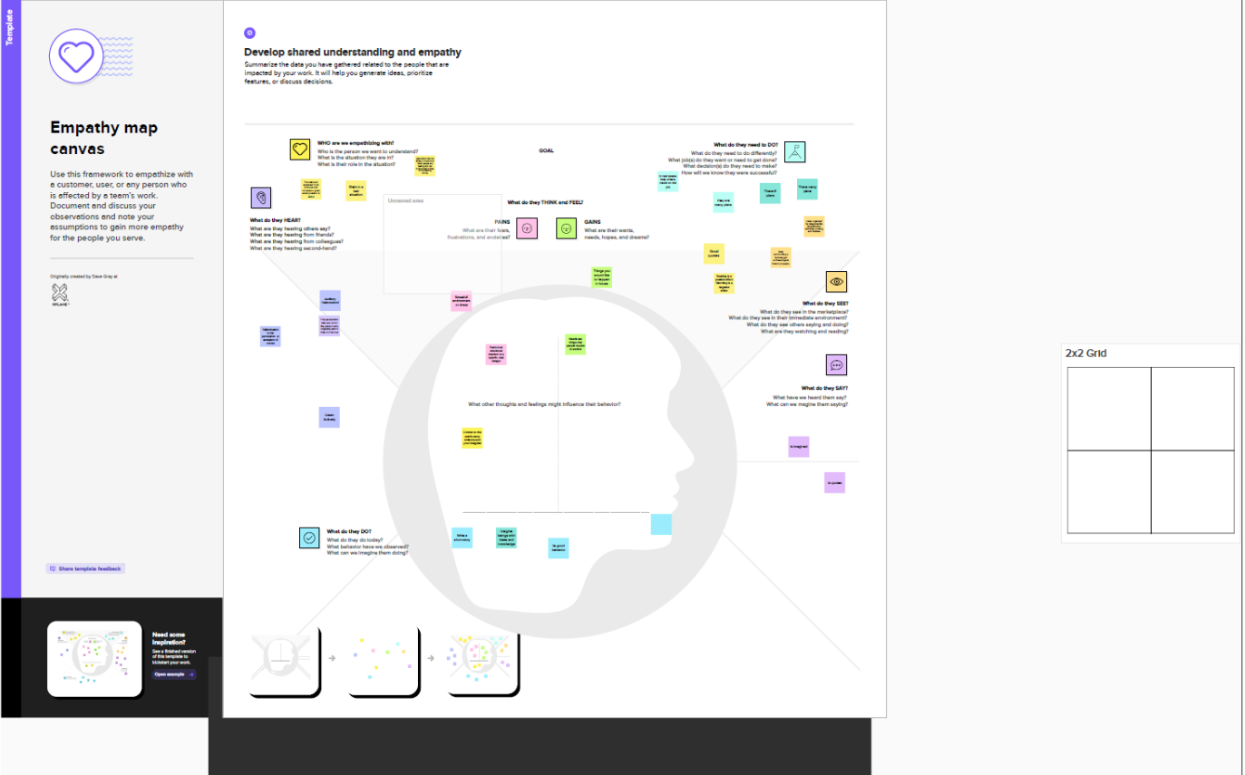

* 1. Ideation & Brainstorming Map

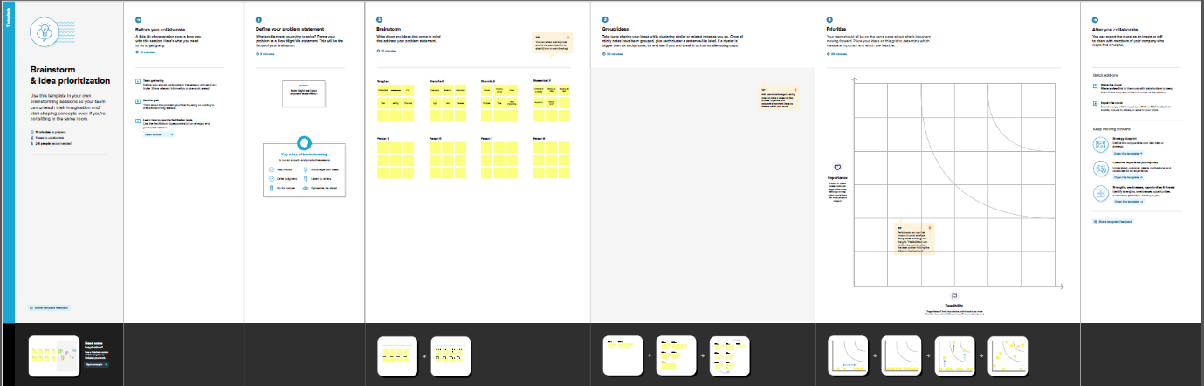

1. Result

3.1 Data Model

|  |  |  |
| --- | --- | --- |
| Object name | Field in the object | |
| Field label | Data type |
| Object 1 | Enter amount | formula |
| Object2 | Total expenses | Travel approval |

* 1. Activity & screenshot

     

1. Trailhead profile Public URL

Team Lead – https://trailblazer.me/id/ppraba22

Team Member 1-https://trailblazer.me/id/ssankari18

Team Member 2- https://trailblazer.me/id/shar45

Team member 3- https://trailblazer.me/id/sezhumalai6

1. ADVANTAGES & DISADVANATGES

ADVANTAGES

* Approvals on time. The entire process of planning and managing a trip is a long and stressful process. ...
* Customize approval workflows. The approval process can differ from company to company. ...
* Increase compliance and reduce costs. ...
* Faster process.

DISAVANTAGES

Think of Tripeur’s platform as the swiss army knife of corporate travel, where every tool you need for corporate travel management is available to you within one platform. Sometimes, no amount of workforce or capital can improve an outdated and broken travel approval system.

Instead, Tripeur and its expense module helps keeps the finance department in the loop by sending stakeholders automated expenditure alerts and reports through all stages of the travel booking experience. Our travel request approval process will ensure it keeps all relevant stakeholders informed and involved in the decision-making process, improving communication and reducing the risk of misunderstandings.

Better yet, our system supports e-receipts and automated reconciliation to help you create a seamless experience for travelers and other stakeholders. We provide you with all the tools necessary to develop a standardized process for examining if travel expenses align with its policies and regulatory requirements.

With such a granular level of control, you will only authorize travel requests that comply with your organizational policies.

Our user-friendly software can tremendously simplify and improve your travel proposals system, where every approval will be instantaneously sent to the mobile devices of the right stakeholders. We can help you perpetually fix your corporate travel inefficiencies and simplify and implement travel request approval workflow while significantly lowering costs.

6.APPLICATIONS

* [About the Sample Application](https://documentation.softwareag.com/naturalONE/natONE836/core/samples/sample-travel.htm#travel-about)
* [Prerequisites](https://documentation.softwareag.com/naturalONE/natONE836/core/samples/sample-travel.htm#sample-travel-prereq)
* [Installing the Sample Application](https://documentation.softwareag.com/naturalONE/natONE836/core/samples/sample-travel.htm#sample-travel-install)
* [Defining the Use of an External Web Browser](https://documentation.softwareag.com/naturalONE/natONE836/core/samples/sample-travel.htm#sample-travel-extweb)
* [Starting the Sample Application](https://documentation.softwareag.com/naturalONE/natONE836/core/samples/sample-travel.htm#sample-travel-start)
* [Logging in as an Employee for Requesting a Business Trip](https://documentation.softwareag.com/naturalONE/natONE836/core/samples/sample-travel.htm#sample-travel-logine)
* [Entering a Travel Request with Flight and Hotel Information](https://documentation.softwareag.com/naturalONE/natONE836/core/samples/sample-travel.htm#sample-travel-request)
* [Adding Additional Expenses to Your Travel Request](https://documentation.softwareag.com/naturalONE/natONE836/core/samples/sample-travel.htm#sample-travel-expenses)
* [Logging in as a Manager for Approving Travel Requests](https://documentation.softwareag.com/naturalONE/natONE836/core/samples/sample-travel.htm#sample-travel-loginm)
* [Approving a Travel Request](https://documentation.softwareag.com/naturalONE/natONE836/core/samples/sample-travel.htm#sample-travel-approve)

7.CONLUSION

While the business travel approval process may seem overwhelming when everything is done manually, this doesn’t have to be the case forever. By creating an organized plan, communicating it well, and using an automated, centralized system, you can change the way your company does business travel.

8.FUTURE SCOPE

* Employee name and contact information.
* The business purpose of the trip.
* Destination details.
* Departure and return dates.
* Predicted travel costs which are broken down by category. For example, airfares, other transportation, accommodation, and meal allowances.
* Notes of any visa requirements for international travel.
* Any relevant comments from the employee's manager.